Enumerated Datatypes and Typedefs assignments

Mandatory
- WAP to define an enum to store designations in an organization. List of possible values are
{E2F=1, E2, E3, E4, E5}
Prompt and read a designation from the user. Then display his designation string such as
Designation | Designation String
E2F | Software Fresher
E2 | Software Engineer
E3 | Senior Software Engineer
E4 | Team Lead
E5 | Senior Team Lead

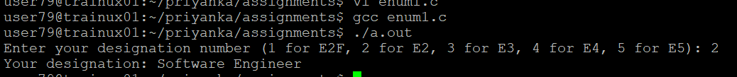
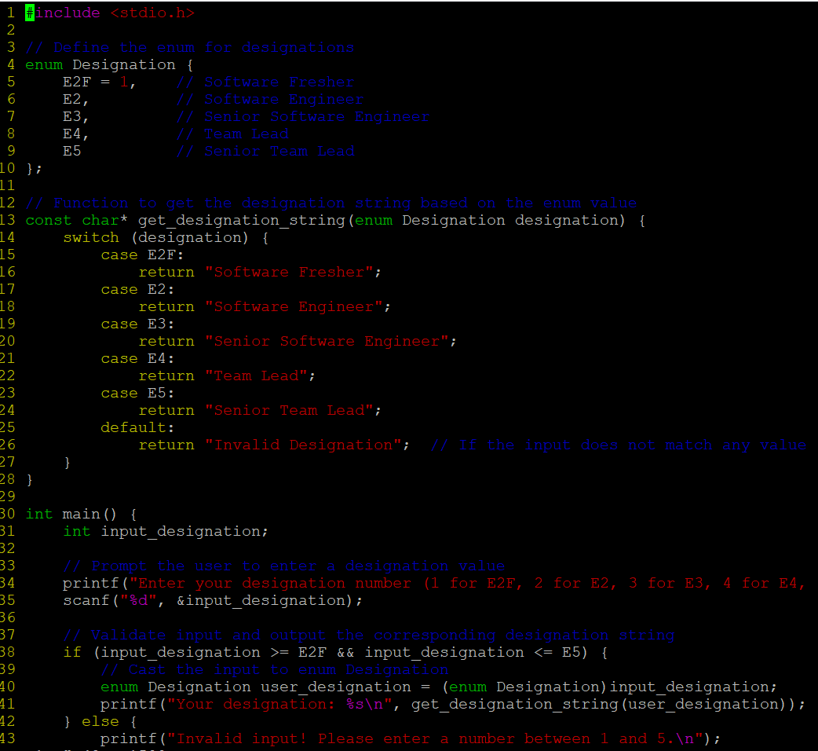
- Define a typedef structure to keep the configuration of putty server. Identify and place all the required members. Create a structure variable and initialize it with user defined values and finally display the contents.

